Laser Engraving Instructions
Attentions：
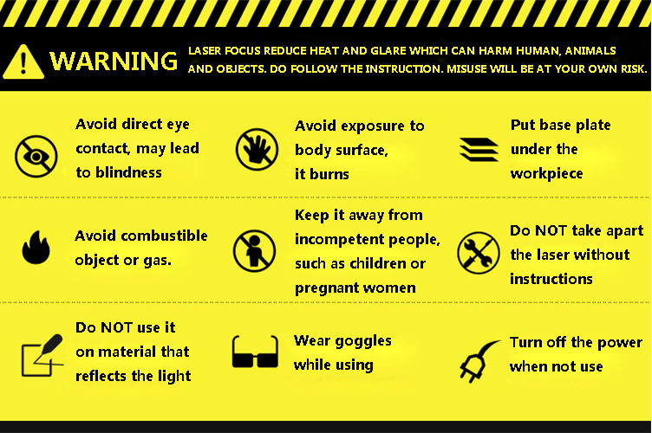
Non-working materials：
It cannot work on any metal, ceramic, jewelry, etc. Also, it cannot work on any material that reflects light or is transparent.
Software：minilaser
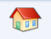
1. Main interface
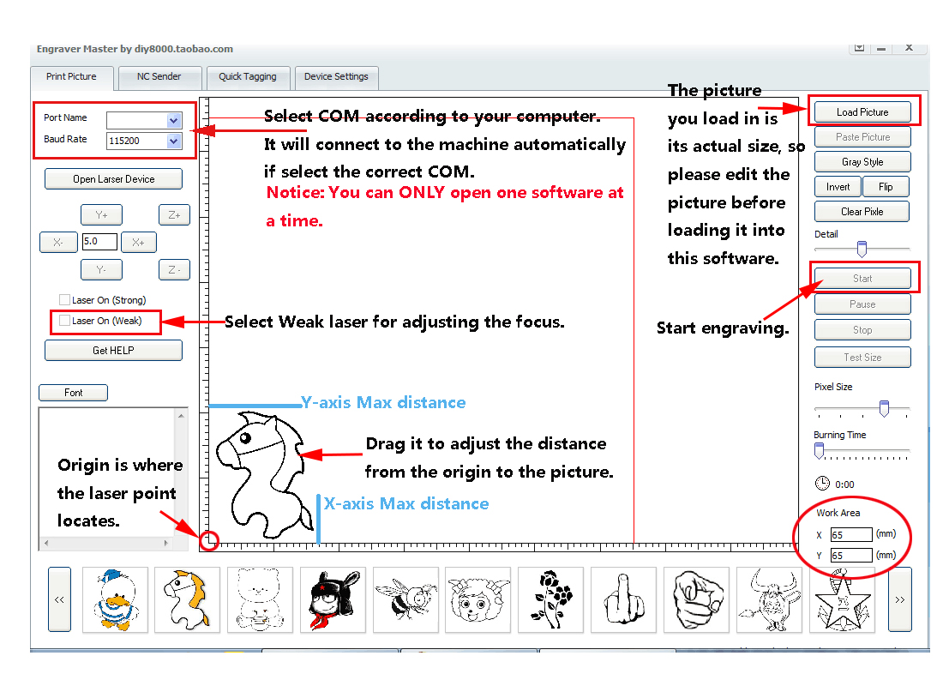
Engraving Position:
Turn on the weak light, it will appear a point on the work piece. Then swivel the knob to adjust the point to the smallest.
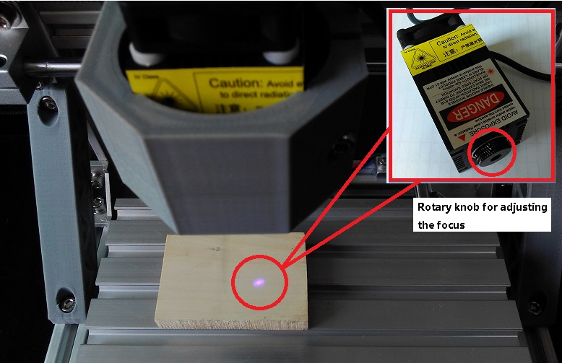
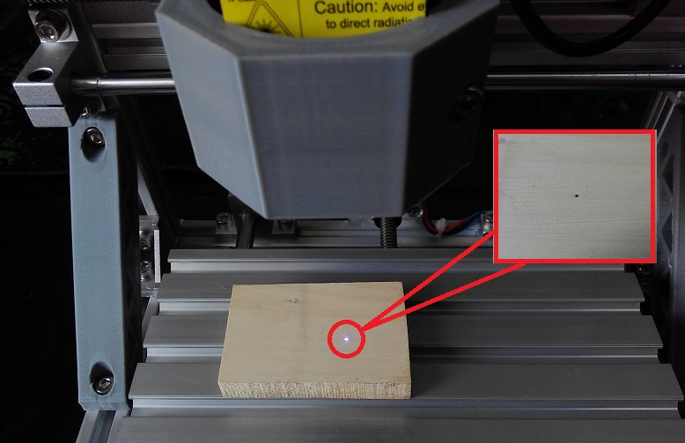
Find the suitable position for your work, then you can start engraving.

